STOCK PORTFOLIO RISK ANALYSIS

Name: Sunitha R
Course: Data Analytics
College: Arcot Sri Mahaalakshmi Women’s College
Date: 29-03-2026

INTRODUCTION
- This project focuses on analyzing stock market data using Python and Power BI.
- The main objective is to understand stock price trends, daily returns, and volatility.

TOOLS USED
- Python (Pandas, NumPy, Matplotlib)
- Jupyter Notebook
- Power BI
- Excel

DATA DESCRIPTION
- The dataset contains stock prices of companies like AAPL, AMZN, MSFT, and TSLA.
- It includes date-wise closing prices used for analysis.

PROCESS
- Collected stock data using Python (yfinance)
- Cleaned and processed the data
- Calculated daily returns
- Calculated volatility
- Exported data to CSV
- Created dashboard in Power BI

VISUALIZATION

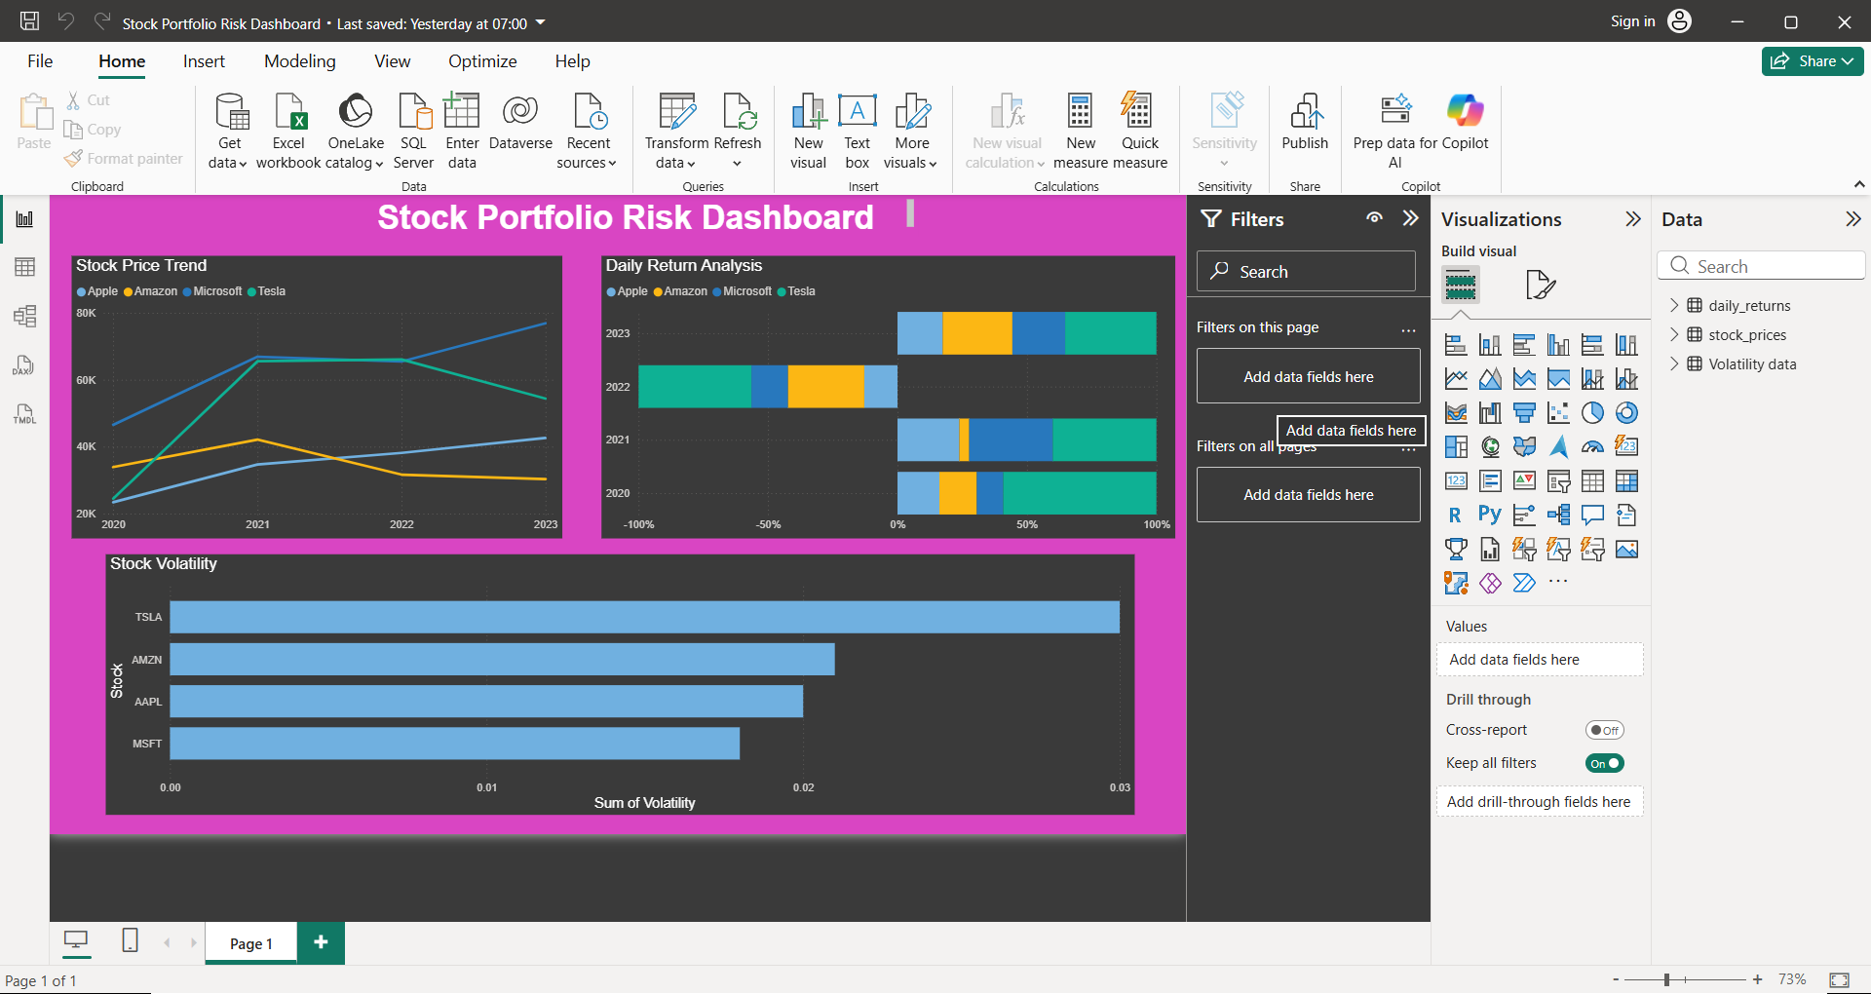

CONCLUSION

- This project helped in understanding stock behavior, risk analysis, and data visualization.
- It improved my skills in Python and Power BI.

